

**Why choose DLC listed products?**

Only DLC listed products go through rigorous testing and verification to ensure you’re getting:

* High performing, energy efficiency LED lighting products
* Supported by energy efficiency programs nationwide

Your Logo Here



**Why choose DLC listed products?**

Only DLC listed products go through rigorous testing and verification to ensure you’re getting:

* High performing control systems to help you save energy
* Supported by energy efficiency programs nationwide

Your Logo Here

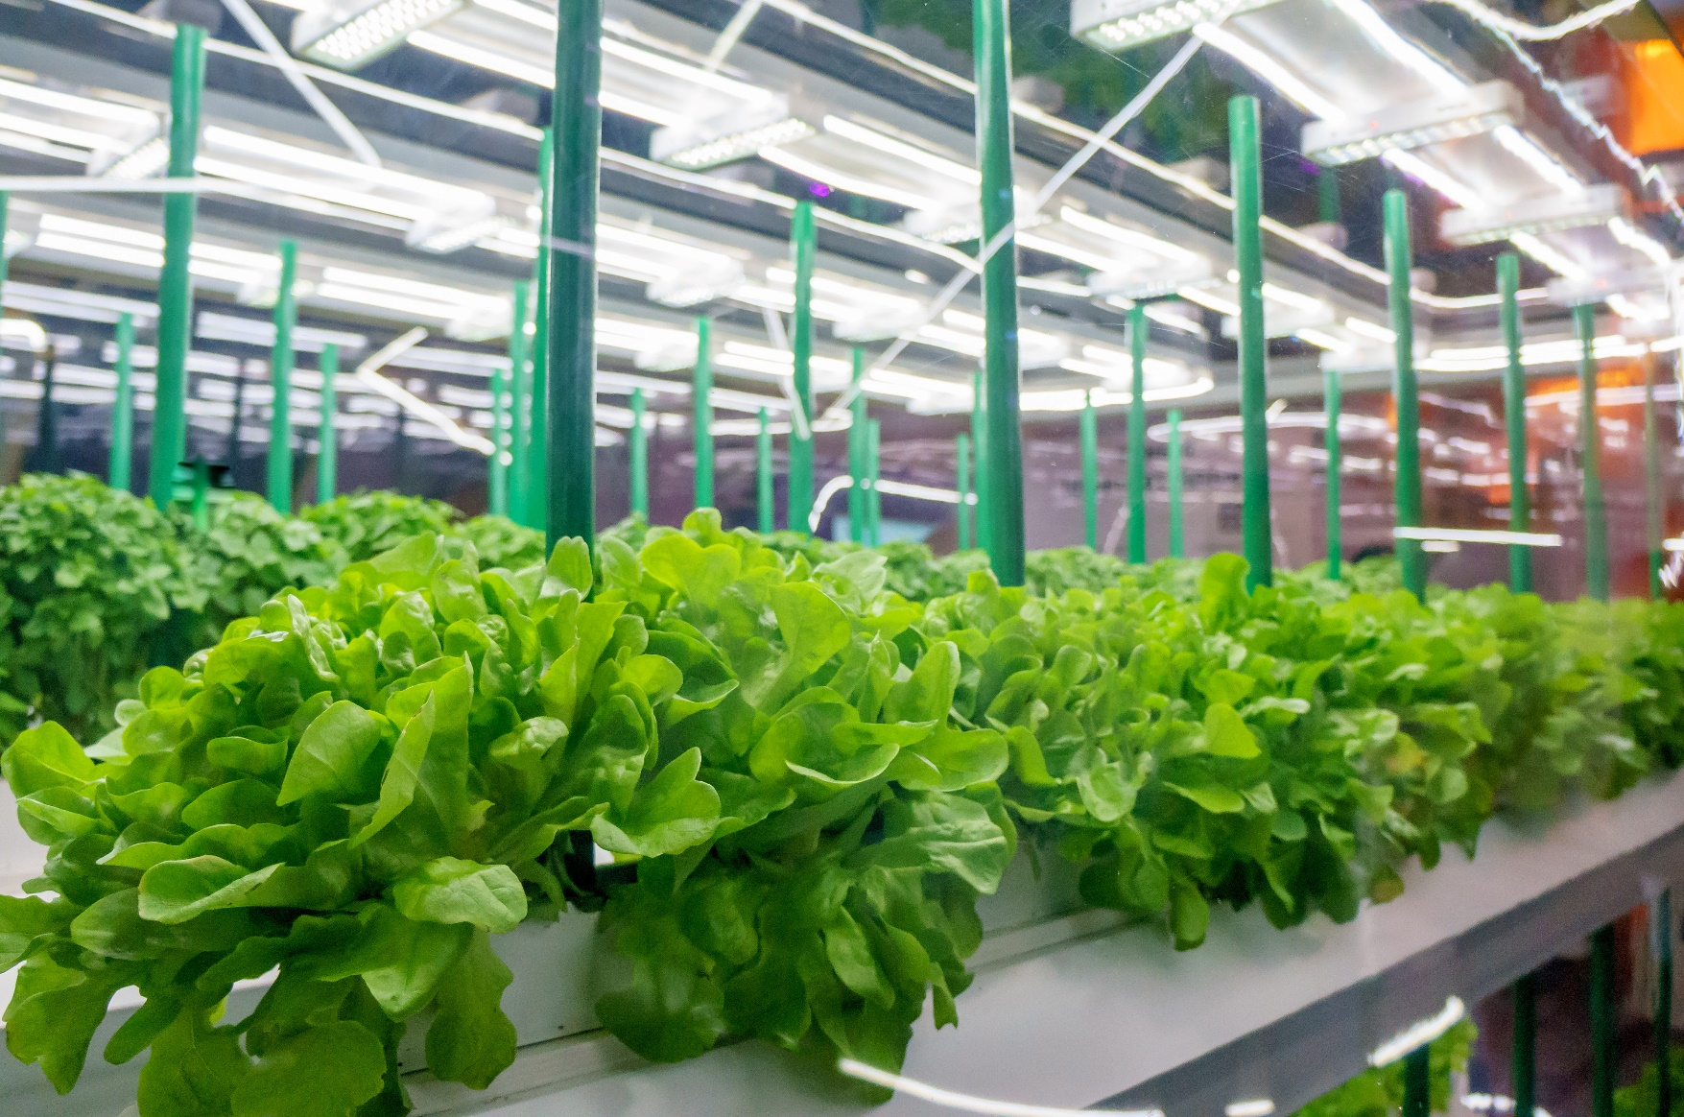

Your Logo Here

Only DLC listed products go through rigorous testing and verification to ensure you’re getting:

* High performing, energy efficient horticultural LED lighting products
* Supported by energy efficiency programs nationwide

**Why choose DLC listed products?**